# Web Developer Portfolio

**Portfolio link:**

<https://sachin-gowda-k.github.io/Assigment2/>

**Project link:**

<https://github.com/Sachin-Gowda-K/Assigment2>

**Screenshots:**

**Home Page :**

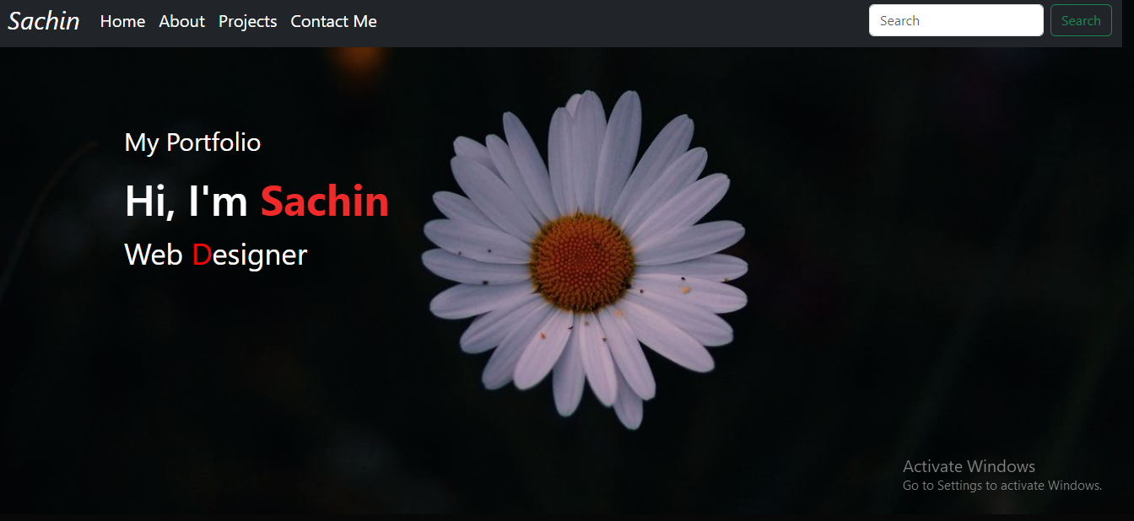

**About Page:**

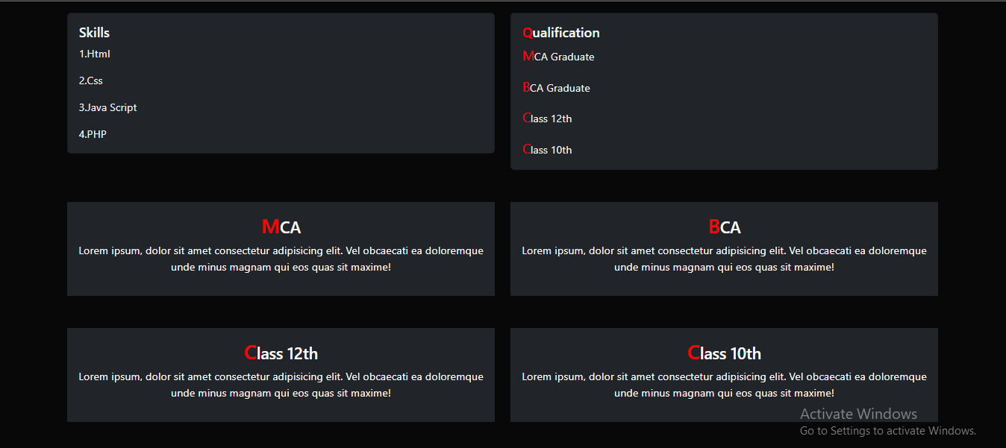

**Projects:**

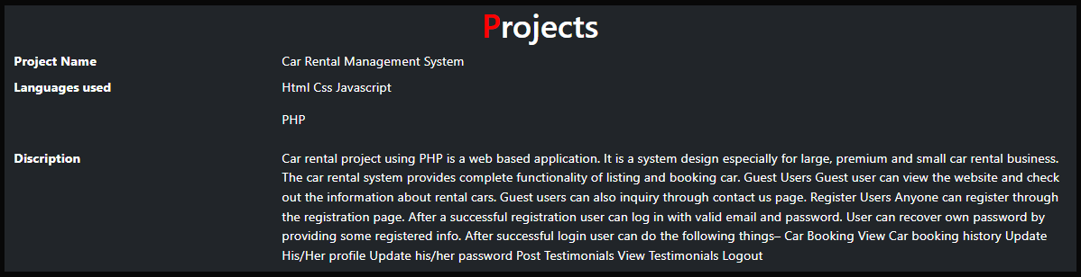

**Contact Us :**

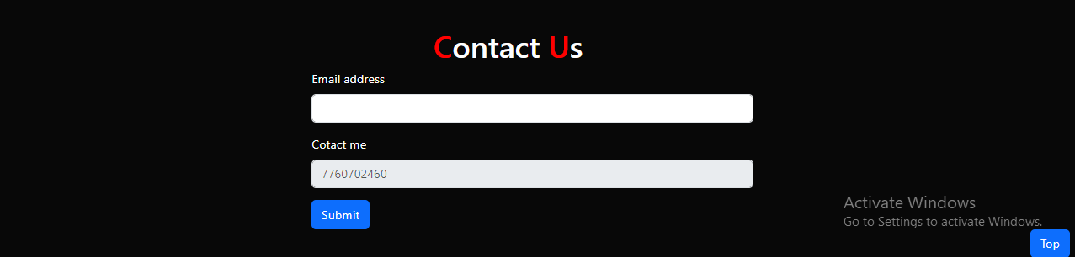

**Project Code:**

**Project Html Code:**

<!DOCTYPE html>

<html lang="en">

<head>

<meta charset="UTF-8">

<meta name="viewport" content="width=device-width, initial-scale=1.0">

<link href="https://cdn.jsdelivr.net/npm/bootstrap@5.3.1/dist/css/bootstrap.min.css" rel="stylesheet"

integrity="sha384-4bw+/aepP/YC94hEpVNVgiZdgIC5+VKNBQNGCHeKRQN+PtmoHDEXuppvnDJzQIu9" crossorigin="anonymous">

<script src="https://cdn.jsdelivr.net/npm/bootstrap@5.3.1/dist/js/bootstrap.bundle.min.js"

integrity="sha384-HwwvtgBNo3bZJJLYd8oVXjrBZt8cqVSpeBNS5n7C8IVInixGAoxmnlMuBnhbgrkm"

crossorigin="anonymous"></script>

<link rel="stylesheet" href="style.css">

<title>My Portfolio</title>

</head>

<body>

<div id="header">

<nav class="navbar navbar-expand-lg navbar-brand navbar-dark bg-dark">

<div class="container-fluid">

<a class="navbar-brand" href="#" id="logo">Sachin</a>

<!-- <img id="img" src="./images/logo.png" alt=""> -->

<button class="navbar-toggler" type="button" data-bs-toggle="collapse"

data-bs-target="#navbarSupportedContent" aria-controls="navbarSupportedContent"

aria-expanded="false" aria-label="Toggle navigation">

<span class="navbar-toggler-icon"></span>

</button>

<div class="collapse navbar-collapse" id="navbarSupportedContent">

<ul class="navbar-nav me-auto mb-2 mb-lg-0 ">

<li class="nav-item">

<a class="nav-link active" aria-current="page" href="#" id="homee">Home</a>

</li>

<li class="nav-item">

<a class="nav-link active" aria-current="page" href="#About">About</a>

</li>

<li class="nav-item">

<a class="nav-link active" aria-current="page" href="#projects">Projects</a>

</li>

<li class="nav-item">

<a class="nav-link active" aria-current="page" href="#contact">Contact Me</a>

</li>

</ul>

<form class="d-flex" role="search">

<input class="form-control me-2" type="search" placeholder="Search" aria-label="Search">

<button class="btn btn-outline-success" type="submit">Search</button>

</form>

</div>

</div>

</nav>

<div class="container" id="home">

<div class="abb">

<p class="p1">My Portfolio</p>

<h2 class="p2">Hi, I'm <a class="sac">Sachin</a></h2>

<p class="ui">Web <a class="d">D</a>esigner</p>

</div>

</div>

</div>

<div id="About">

<div class="container">

<div class="row my-5">

<div class="col-sm-6 mb-3 mb-sm-0">

<div class="card bg-dark">

<div class="card-body ">

<h5 class="card-title text-light"><a id="Skills">Skills</a></h5>

<p class="card-text text-light">1.Html</p>

<p class="card-text text-light">2.Css</p>

<p class="card-text text-light">3.Java Script</p>

<p class="card-text text-light">4.PHP</p>

<!-- <a href="#" class="btn btn-primary">Go somewhere</a> -->

</div>

</div>

</div>

<div class="col-sm-6">

<div class="card bg-dark">

<div class="card-body">

<h5 class="card-title text-light"><a class="q" id="quail">Q</a>ualification</h5>

<p class="card-text text-light"><a class="m">M</a>CA Graduate</p>

<p class="card-text text-light"><a class="m">B</a>CA Graduate</p>

<p class="card-text text-light"><a class="m">C</a>lass 12th</p>

<p class="card-text text-light"><a class="m">C</a>lass 10th</p>

<!-- <a href="#" class="btn btn-primary">Go somewhere</a> -->

</div>

</div>

</div>

</div>

</div>

</div>

<div id="About1">

<div class="cointainer">

<div class="container overflow-hidden text-center ">

<div class="row gy-5 ">

<div class="col-6">

<div class="p-3 bg-dark">

<h4><a class="ma">M</a>CA</h2>

<p>Lorem ipsum, dolor sit amet consectetur adipisicing elit. Vel obcaecati ea doloremque

unde minus magnam qui eos quas sit maxime!</p>

</div>

</div>

<div class="col-6">

<div class="p-3 bg-dark">

<h4><a class="ma">B</a>CA</h2>

<p>Lorem ipsum, dolor sit amet consectetur adipisicing elit. Vel obcaecati ea doloremque

unde minus magnam qui eos quas sit maxime!</p>

</div>

</div>

<div class="col-6">

<div class="p-3 bg-dark">

<h4><a class="ma">C</a>lass 12th</h2>

<p>Lorem ipsum, dolor sit amet consectetur adipisicing elit. Vel obcaecati ea doloremque

unde minus magnam qui eos quas sit maxime!</p>

</div>

</div>

<div class="col-6">

<div class="p-3 bg-dark">

<h4><a class="ma">C</a>lass 10th</h2>

<p>Lorem ipsum, dolor sit amet consectetur adipisicing elit. Vel obcaecati ea doloremque

unde minus magnam qui eos quas sit maxime!</p>

</div>

</div>

</div>

</div>

</div>

</div>

<div id="projects">

<div class="container ">

<dl class="row bg-dark my-5">

<h1 class="text-center"><a class="maa">P</a>rojects</h1>

<dt class="col-sm-3">Project Name</dt>

<dd class="col-sm-9">Car Rental Management System</dd>

<dt class="col-sm-3">Languages used</dt>

<dd class="col-sm-9">

<p>Html Css Javascript</p>

<p>PHP</p>

</dd>

<dt class="col-sm-3">Discription</dt>

<dd class="col-sm-9">Car rental project using PHP is a web based application. It is a system design

especially for large, premium and small car rental business. The car rental system provides complete

functionality of listing and booking car.

Guest Users

Guest user can view the website and check out the information about rental cars.

Guest users can also inquiry through contact us page.

Register Users

Anyone can register through the registration page.

After a successful registration user can log in with valid email and password. User can recover own

password by providing some registered info.

After successful login user can do the following things–

Car Booking

View Car booking history

Update His/Her profile

Update his/her password

Post Testimonials

View Testimonials

Logout

</dd>

</dd>

</dl>

</div>

</div>

<div id="contact">

<div class="container">

<h1 class="text-center"><a class="maa">C</a>ontact <a class="maa">U</a>s</h1>

<form id="cont" class="" method="#">

<div class="mb-3 bg">

<label for="exampleInputEmail1" class="form-label">Email address</label>

<input type="email" class="form-control" id="exampleInputEmail1" aria-describedby="emailHelp">

</div>

<div class="mb-3">

<label for="disabledTextInput" class="form-label">Cotact me </label>

<input type="text" id="disabledTextInput" class="form-control" disabled placeholder="7760702460">

</div>

<button type="submit" class="btn btn-primary">Submit</button>

</form>

</div>

</div>

<div class="cointainer">

<div class="d-grid gap-2 d-md-flex justify-content-md-end">

<button class="btn btn-primary me-md-2" type="button"> <a href="index.html" class="btt">Top</a></button>

<!-- <button class="btn btn-primary" type="button">Button</button> -->

</div>

</div>

</body>

</html>

**Project Css code :**

html{

scroll-behavior: smooth;

}

body{

background-color: #080808;

color: white;

}

#header{

width: 100%;

height: 100vh;

background-image: url('./images/back.jpg');

background-size: cover;

background-position: center;

}

#img{

/* width: 65px; */

}

#logo{

font-size: 30px;

font-style:oblique;

text-transform: capitalize;

}

.abb{

margin-left: 3%;

margin-top: 8%;

}

.p1{

font-size: 30px;

}

.p2{

font-size: 50px;

}

section{

color: red;

}

.sac{

color: rgb(241, 41, 41);

text-decoration: none;

font-weight: bold;

}

.d,.q, .m{

color: red;

text-decoration: none;

}

.m{

font-size: 20px;

}

.ma{

font-size: 30px;

color: red;

text-decoration: none;

}

.maa{

color: red;

text-decoration: none;

}

.btt{

text-decoration: none;

color: white;

cursor:pointer;

}

.ui{

font-size: 35px;

}

#Skills:hover{

color: red;

cursor:pointer;

}

#quail:hover{

cursor:pointer;

color: white;

}

#cont{

/* background-color: red; */

width: 45%;

margin-left: 30%;

}